Ika Widya Ambarwati

Juara Coding Batch2 QA

1. Tampilkan data Name, Region, Population pada tabel Country dan Language berdasarkan Country Population diatas rata-rata

Jawab :

Untuk mencari ratarata : SELECT AVG(Population) FROM country = 25434098.1172

SELECT country.Name, country.region, country.Population, country.Name FROM country JOIN countrylanguage ON countrylanguage.CountryCode = country.Code WHERE country.population > 25434098.1172

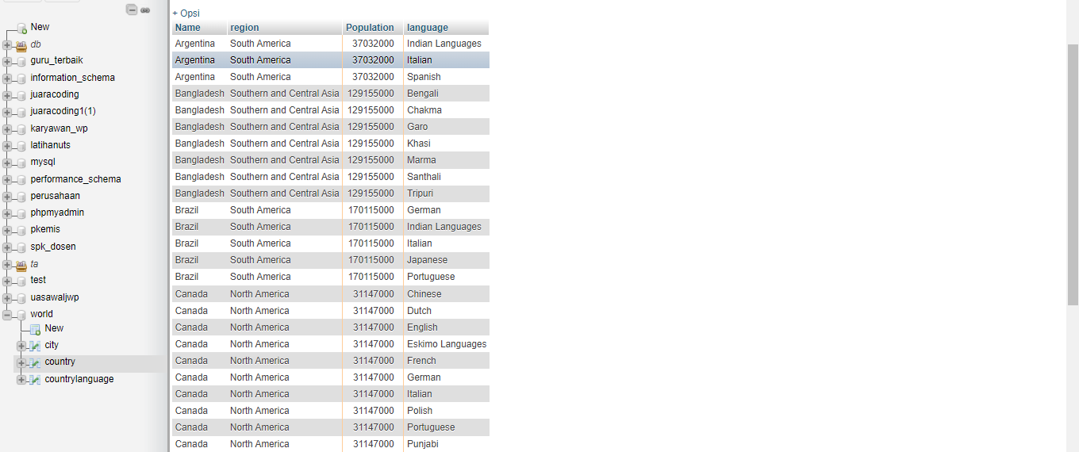

1. Tampilkan data Name, District, Population pada tabel City dan Name Country berdasarkan City Population diatas rata-rata

Jawab :

Untuk mencari ratarata : SELECT AVG(Population) FROM city = 350468.2236

SELECT city.Name, city.District, city.Population, country.Name FROM city JOIN country ON city.CountryCode = country.Code WHERE city.population > 350468.2236

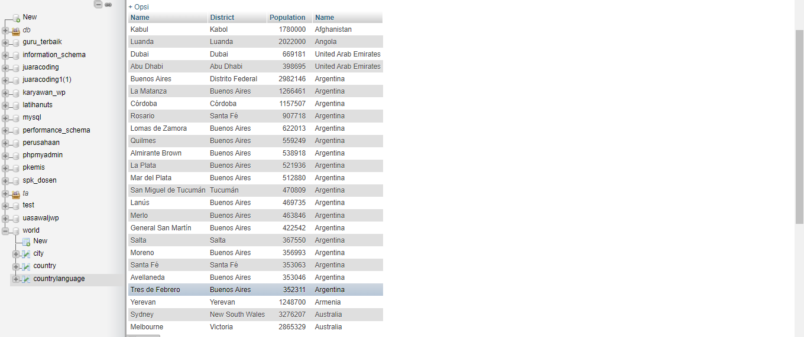

1. Tampilan data Name, Region, Population pada tabel Country berdasarkan IndepYear null

Jawab :

Select name , region , population from country where indepyear is null

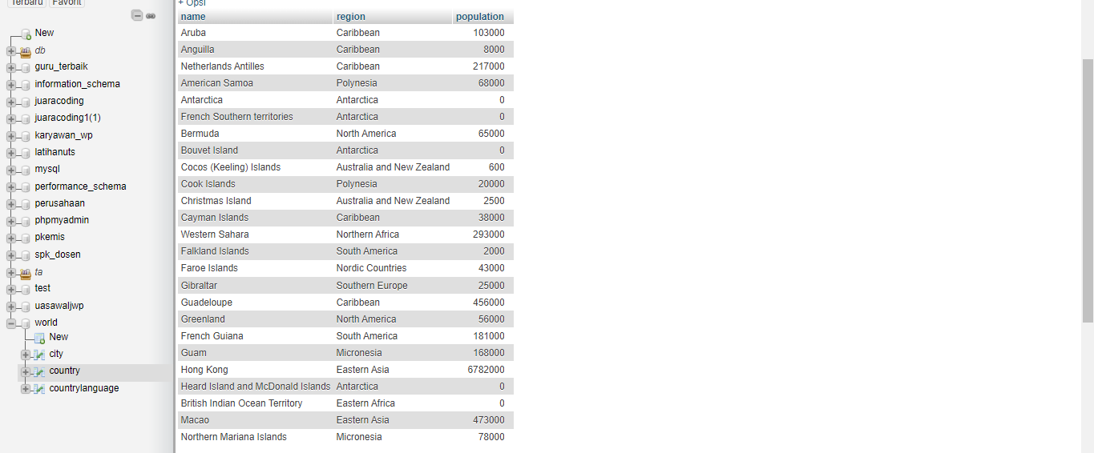

1. Tampilkan data jumlah Country berdasarkan Region yang memiliki Jumlah Country diatas 5